RETROSPECTIVE STUDY

TRANSFORMING LIVES AND LIVELIHOODS IN CHEMIN RAIL

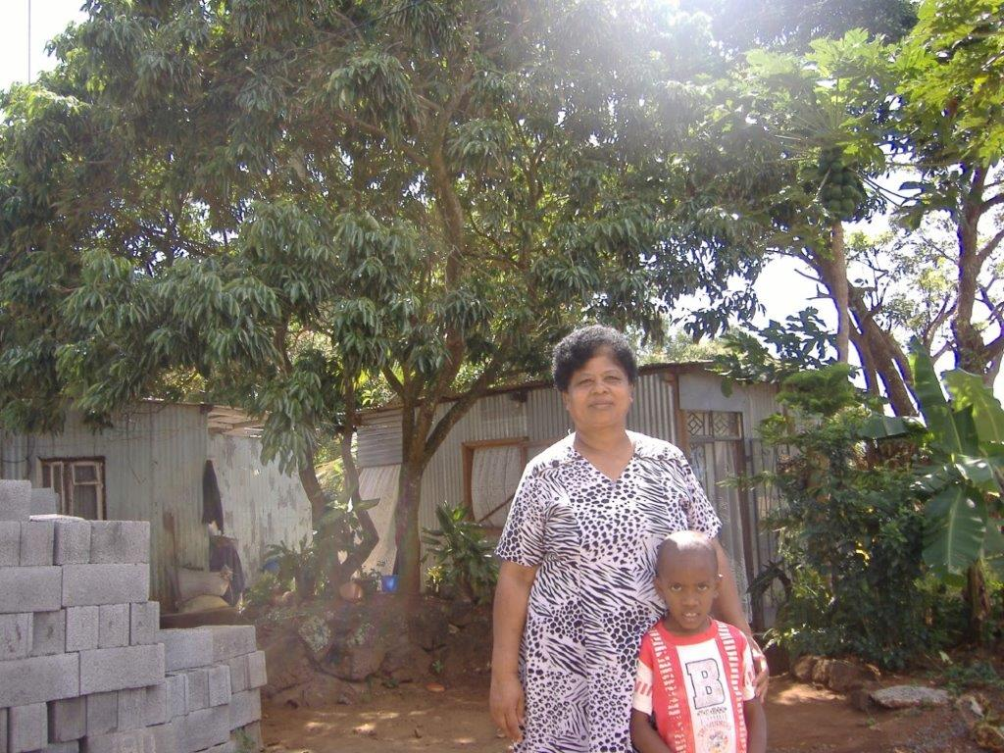

TABLE OF CONTENTS

EXECUTIVE SUMMARY 1
1. INTRODUCTION 3
1.1 OVERVIEW AND OBJECTIVE 3
1.2 BACKGROUND 3
The name ‘Chemin Rail’ 3
The origin of Chemin Rail 4
2. RETROSPECTIVE CONTEXT 5
2.1 1990 – 2005: A TIME OF ADVERSITY AND RESILIENCE 5
2.2 2005 – 2017: A TIME FOR HOPE, DISILLUSION AND TRUST 8
Community v/s Development partners 8
FJL’s investment in Chemin Rail 11
3. ADDRESSING THE VULNERABILITIES/NEEDS OF THE COMMUNITY AT CHEMIN RAIL 18
3.1 SHELTER: THE CHEMIN RAIL SOCIAL HOUSING PROJECT 18
3.2 EDUCATION 23
3.3 HEALTH 23
3.4 ENVIRONMENT 24
3.5 EMPLOYMENT 24
3.6 SAFETY AND SECURITY 25
3.7 A FEW INVESTMENT FIGURES 25
4. PROFILE OF HOUSEHOLDS, 2018 27
5. SUMMARY OF VULNERABILITIES/NEEDS ADDRESSED BY FJL 30
6. THE REASEARCH TEAM IN CHEMIN RAIL 32
7. CONCLUSION AND WAY FORWARD 34
8. ANNEXES 36
8.1 ANNEX 1 36

EXECUTIVE SUMMARY
For 12 years, Fondation Joseph Lagesse (FJL) has provided social and development support to the community of Chemin Rail. Chemin Rail is a small locality situated in the north east of Mauritius. Once a community made vulnerable by socio-economic issues (lack of education, unemployment, substance abuse and associated violence, lack of access to existing services, and sub-standard housing), Chemin Rail is now an empowered community. With support from FJL, the community now has:
- Access to basic needs, including:
  - safe and secure housing through the construction of housing units; and
  - proper sanitary facilities to support good health and hygiene practices.
- Acquired key development components, including:
  - improved access to existing public services such as public health;
  - 0% unemployment rates; and
  - an improvement in formal education levels within the community (all children in the community are currently attending formal educational structures).
Some of the key investments made by FJL in the development of Chemin Rail include:
- The health and care of the community (both for individual community members as well as the community as a whole);
- Improving formal education levels in the community by:
  - raising community awareness of the importance and impact of education on personal and community development; and
  - Changing community behaviour to promote positive education practices.
- Providing adult community members with activities to build local capacity and increase employment rates; and
- Providing all community members with safe and secure housing (including proper sanitary facilities).
During these 12 years, FJL invested approximately Rs 33 million in the development of the community.
In its work with the community, FJL implemented several best practices, and also identified several lessons learnt for future community development initiatives. These included:
- Identifying local leaders and building their capacity to lead the development process of their community (including to mobilise community members);
- Ensuring strong consultation which ensures that communities have a voice, and that they are given the opportunity to identify, prioritise and analyse issues, and eventually lead their own development initiatives;
- Stronger planning to ensure that (1) activities meet community needs and can be evaluated to measure impact, and (2) have a sustainable exit strategy;
- Providing strong, two-way communication channels between the community and FJL to promote mutual trust and partnership, and ensure quick resolutions of miscommunication; and
- Improving communication and planning with other stakeholders and partners to:
- help FJL identify efficient and effective collaborations; and
- ensure that all partners are delivering the same messages to communities.
The activities implemented by FJL have had mixed successes: Some activities which had little to no community consultation (e.g. Swimming lessons and Beekeeping lessons) have shown limited success. Other interventions, such as the construction of safe and secure housing for community members, while very challenging, has proven very successful.
This retrospective study is written proof that success follows effective community consultation and the identification of the needs and priorities of communities. Moreover, while FJL’s investment in Chemin Rail is considerable, this study also shows that the community has not only had its basic needs met, but now has sufficient capacity to continue its own future development initiatives.

1. INTRODUCTION

1.1 OVERVIEW AND OBJECTIVE
This report is a retrospective study of the transformed lives and livelihoods of the community that constitutes the Chemin Rail locality after interventions carried out by the not-for-profit organisation, Fondation Joseph Lagesse (FJL); in particular after the completion of a social housing project. The report provides a historical narrative and factual description of the lives, then and now, of 20 families of Chemin Rail.
More specifically, it will examine the families’ transition out of the cycle of poverty, the dynamics behind this social change, and the impact of this shift on their lives and livelihoods. This analysis is discussed from two distinct perspectives, namely, that of the community members and that of the staff of Fondation Joseph Lagesse.

1.2 BACKGROUND

The name ‘Chemin Rail’
chemin [ʃ(ə)mɛ̃] nm (gén) path; (route) lane; (piste) track.
rail [rɑj] nm rail. (voie) les~s the rails, the track; transport ~-route road-rail transport.

Chemin Rail is a small locality in the north east of Mauritius, in the district of Rivière du Rempart. It is nestled along the river Rivière du Rempart and a disused railway line. The neighbourhood was originally called Lor Pon (English: On the bridge), since it stretches along and across the bridge over the river; but has gradually been known by the name of Chemin Rail.
The words ‘Chemin’ ‘Rail’ are French for ‘Railroad’ (Kreol: Sime Rel) and the name is thus infused with the history of this area of Mauritius, which harboured part of the Mauritian railway network, the North line, which started operation in 1864 and was closed down a century later. The railway tracks are still present to this day.

The origin of Chemin Rail
The locality of Chemin Rail emerged after a group of poverty-stricken individuals, predominantly of Kreol origin, employed by the Mon Loisir Sugar Estate and in need of housing started to occupy a plot of land to build their homes and house their families. With meagre resources, they had illegally resided on the plot of land for more than 50 years and lived in makeshift homes with minimal amenities and in precarious conditions. Living on the margins of society, the severity of their economic and social hardship was such that their integration into mainstream development would be (and has been) challenging and arduous.

2. RETROSPECTIVE CONTEXT
This retrospective study was conducted through consultative meetings from July to November 2018 with community members and the staff (current and former) of Fondation Joseph Lagesse. In addition, the use of participatory tools allowed community members to reflect on and communicate their perspective of the transitional development of their community.

2.1 1990 – 2005: A TIME OF ADVERSITY AND RESILIENCE
Life in Chemin Rail, then Lor Pon, was difficult and strewn with vulnerabilities. While the 20 families had a space to build their homes, economic poverty resulted in them living in sub-standard shelters. This made them vulnerable to various socio-economic adversities, namely:
- Safety and security: With poor shelter and the prevailing geographical layout, households were vulnerable to disasters such as cyclones. Community members describe how their houses were often severely damaged by cyclones: corrugated iron roofs and doors being ripped off their foundations. Adult community members remember very vividly the cyclones Hollanda and Dina, during which they had to seek shelter in the nearest local community centre. Due to its location, the area was also vulnerable to flooding. Residents had to seek alternative shelter and lost many of their possessions and valuables during heavy rains.

“Koma ena lapli, delo rantre. Nou ti pe pas nou lavi dan lekol ek sant.”

- Health and care: With only one water source and only four sanitary facilities for all the households, community members found it difficult to maintain adequate health and hygiene practices. This resulted in many community members (especially children) suffering from skin infections, such as scabies, and water borne diseases, such as gastroenteritis.

Residents also suffered from high stress levels and mental health issues. It is also important to note the high prevalence of disabilities (physical and mental) among the residents of Chemin Rail. In addition, community members relied on traditional medicine to address their health issues.
The economic hardship in Chemin Rail has exposed the inhabitants to other societal adversities, such as substance abuse and violence, which were major health concerns in the community. The community children were particularly vulnerable to the prevailing physical, verbal and sexual violence. This resulted in an environment of insecurity that caused division within the community.
- Education and employment: Education levels in the community were low. Many children struggled to adapt to an education system that did not encourage their integration, learning and positive development. These children subsequently dropped out of school at an early age. Illiteracy was high in the community, and parents did not have the skills and tools to support the education of their children. Furthermore, the high unemployment rate in Chemin Rail created a barrier to the personal and professional development of community members.

“Nou ti ena boukou problem.”

- Environment: Many community members relied on subsistence farming, with a few of them rearing animals for income generating purposes; although the community space was not conducive for such practices. Stray dogs were also a nuisance and a health hazard. In addition, the lack of adequate sanitary facilities and no proper waste management were major environmental issues.

“Lavi ti margoz.”
In spite of all the adversities faced by the community, the residents demonstrated strong inherent character traits that allowed them to withstand the harsh conditions they faced, namely:
- Resilience: Chemin Rail is a community built on resilience. During the hardest times, the community members supported each other and weathered many storms that came their way. This resilience within the community has not only helped Chemin Rail to survive, but it is also the root of the development that has occurred and which has now made the community what it is today.

- Leadership: Identifying local leaders is one of the first steps in mobilising communities and engaging in community development. While there are several key leaders in Chemin Rail, the late Solange Gopaul stood out as the leader that drove the community’s development initiatives. Key interviewees describe Solange as the beam that held the community together, and the driving wheel behind Chemin Rail’s development.

With no formal education, Solange did not let illiteracy stop her from ensuring her place as a leader, as well as, pursuing her personal and professional development. A mother of 2 children and 5 grandchildren, Solange took the time to ensure her neighbours’ welfare: she provided vulnerable children in the locality with food and shelter, and encouraged them to pursue their education. With a vision firmly fixed towards a better future for all her peers, Solange forged ahead, and advocated for her, and her community’s, rights vis-à-vis the public authorities and Fondation Joseph Lagesse for decent households.

Solange Gopaul of Chemin Rail

2.2 2005 – 2017: A TIME FOR HOPE, DISILLUSION AND TRUST

Community v/s Development partners
Solange led her fellow community leaders to present their case and needs (especially the need for improved shelter) to Mon Loisir Sugar Estate. Although Mon Loisir Sugar Estate was very receptive to their needs and committed itself to provide support, after quite a while without any news, the community began to despair.
“Nou atann, atann. Pa tann nannye. Nou koumans dekouraze.”
After being contacted by Mon Loisir Sugar Estate in early 2006, and with the help of a non-profit organisation from the area, Anou Grandi, Anne Rogers and Genevieve De Souza (then President and Programme Manager of FJL, respectively) made first contact with the community at Chemin Rail. Their objective was to listen and get to know the community and assess its needs, primarily through community consultations.
While they were very welcomed, they observed some form of scepticism from the community: “Another two people coming with empty promises”. One of the many weaknesses in community development is that too often communities are subject to constant assessments that do not result in concrete and sustainable actions. This leads to communities having a lack of trust in future support and partners.
Community meetings were first held in the locality under mango trees or on people’s makeshift verandas.
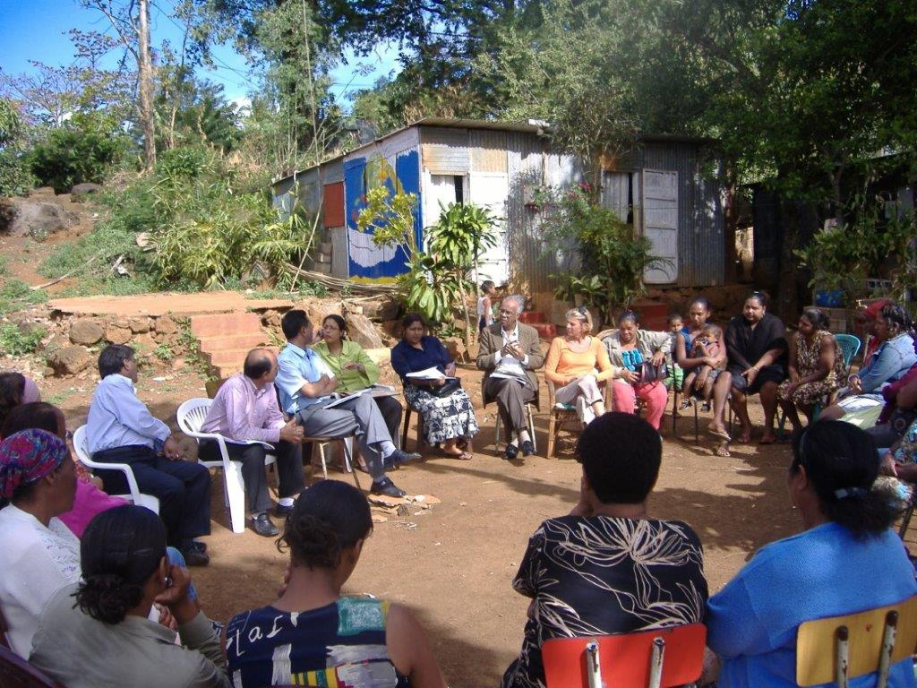Community meeting under mango trees, 2007
No records of these meetings were kept and there are no indications that these meetings used participatory tools that allowed community members (especially those with low education levels) to identify and reflect on issues affecting them and develop community-led initiatives. However, FJL’s frequent physical presence in Chemin Rail, helped to create a level of trust between both parties.
Moreover, FJL worked towards empowering local leaders within the community. The community was asked to identify its representatives who would become the “porte parole” of all the residents of Chemin Rail and who would closely collaborate with the two social workers recruited by FJL to work on the Chemin Rail project.
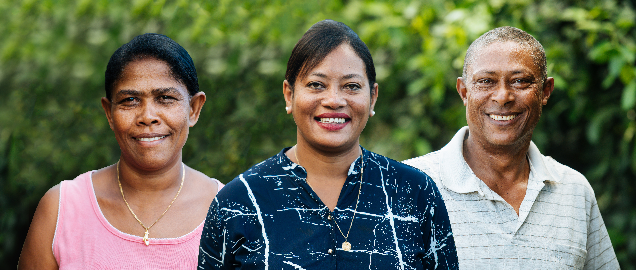Community representatives: Sybille (left), Vanina (centre) and Mario (right)
There followed many years of community meetings, assessments, “accompagnement” and the investment in community-based activities that were primarily focused on health and education. During this time, the following key vulnerabilities or needs were identified:

Community consultations and assessments revealed that the community did not have its basic needs met. The biggest and most urgent priority identified by the community members was a lack of decent housing. In 2006, along with the development of health and education activities, FJL decided to invest its resources and energy in supporting the development of decent housing for the residents of Chemin Rail.
“Nou ti pe rev nou nouvo lakaz tou le swar.”

FJL’s investment in Chemin Rail
FJL’s first intervention in the community, in 2008, was the funding of the medical treatment of Maëva Isidore, (then aged 7). Maëva was a resident of Chemin Rail and living with heavy mental and physical disabilities. In 2009 and 2011, Maëva underwent two more medical interventions which were funded by FJL.
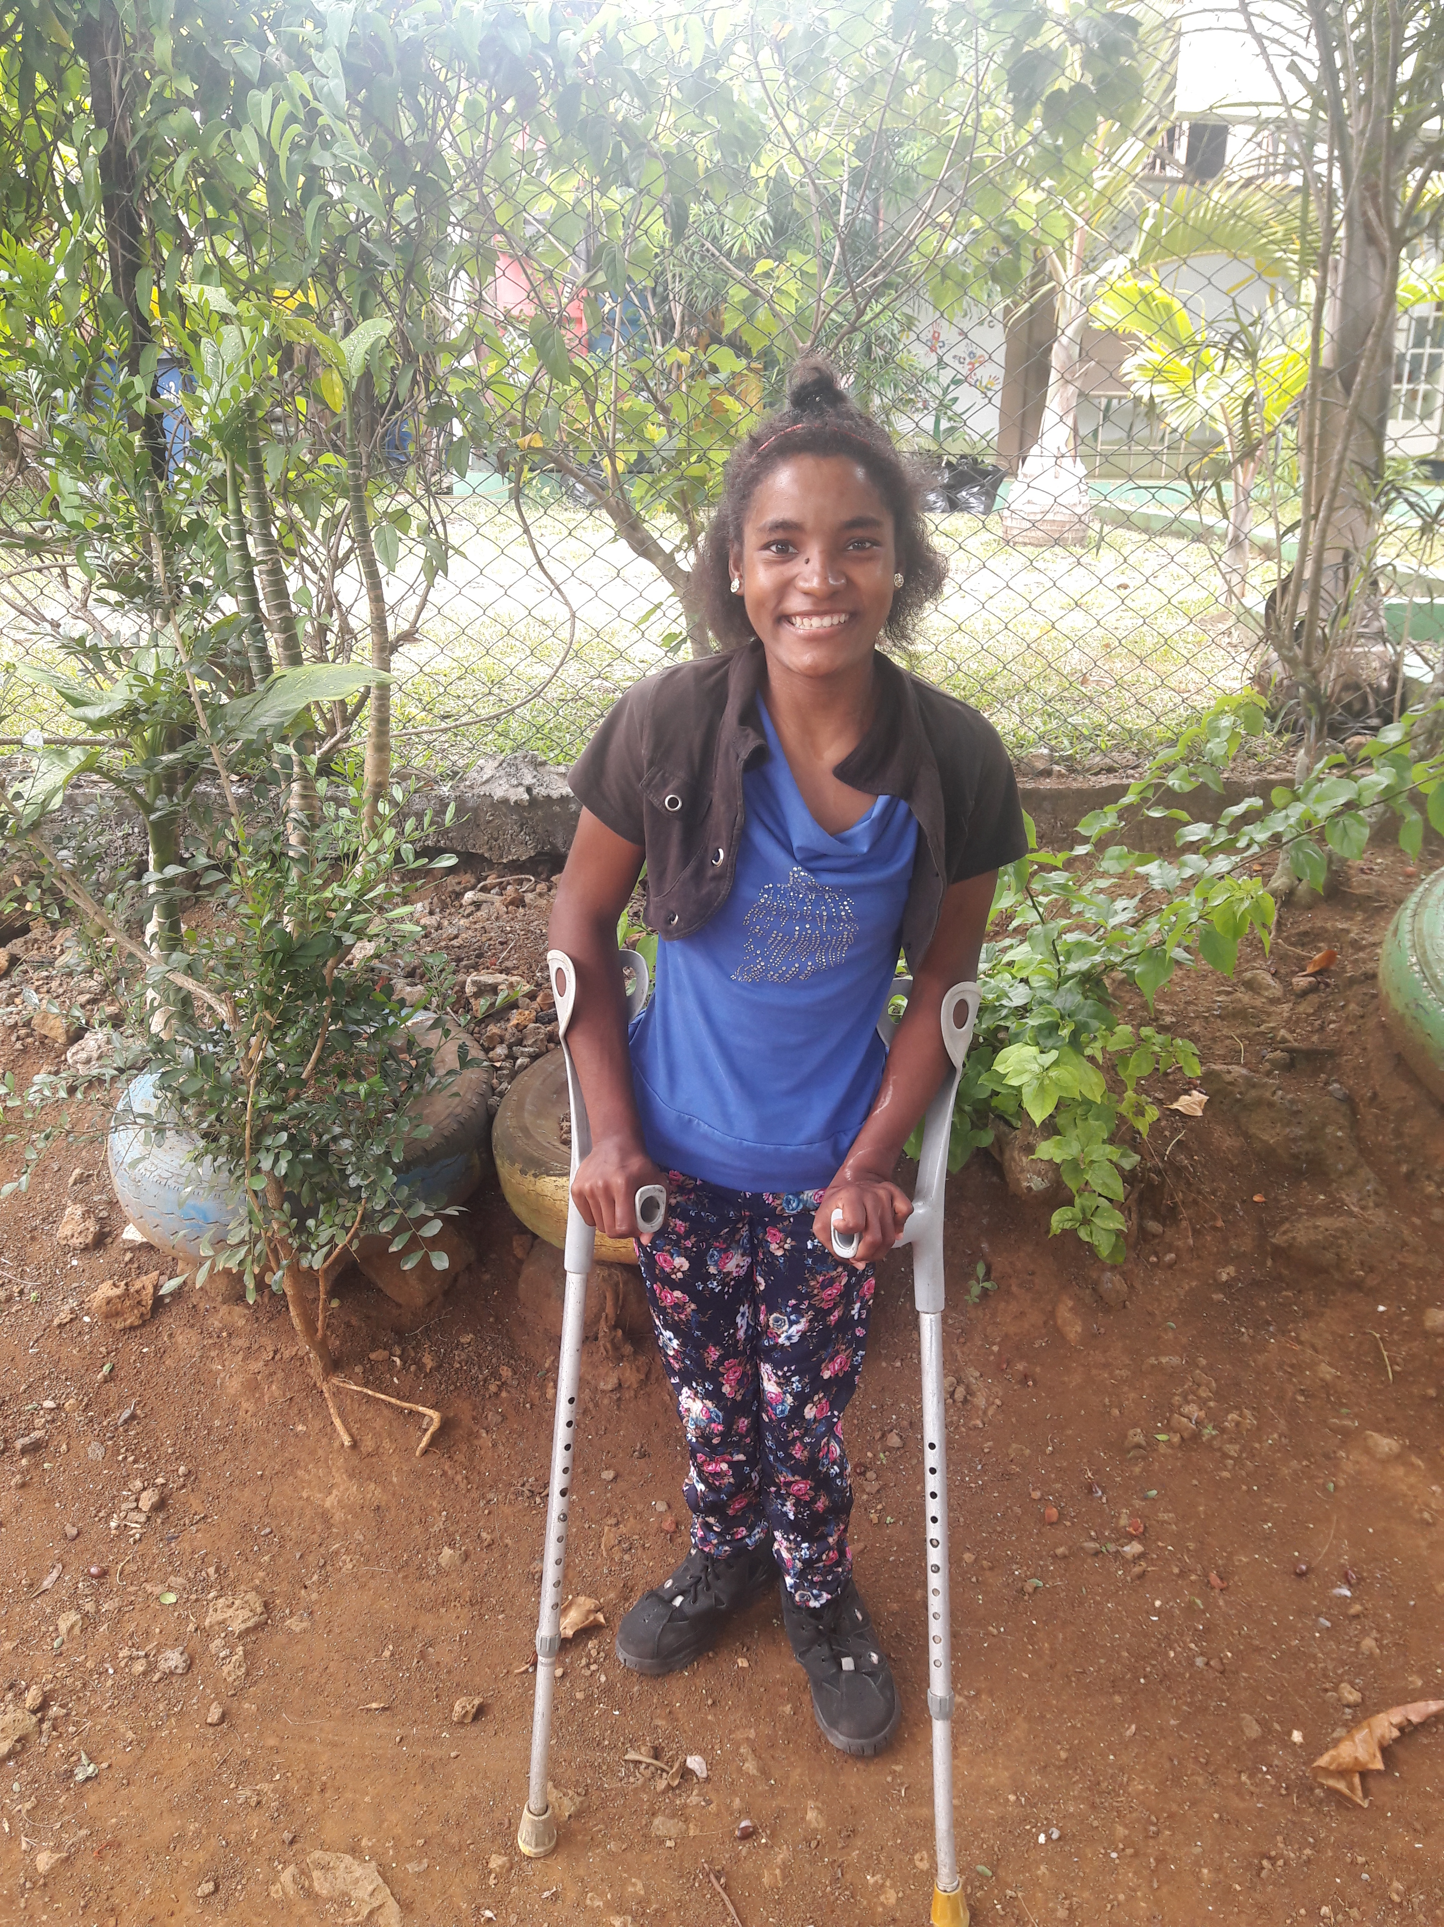
Maëva Isidore aged 11, 2011
The first event organised in the community was the HIV candlelight memorial. Although there are no indications that HIV/AIDS affected the community, community members seemed to have appreciated the memorial service in their community, and identified this as a highlight in their community’s timeline. According to the residents of Chemin Rail, this national event has reinforced the cohesion within their community.
A major project that FJL invested in was the building of the Chemin Rail learning centre. In light of Chemin Rail’s geographical location and inaccessibility by heavy vehicles, FJL faced many physical challenges during the setting up of the centre. It was noted that FJL had to work closely with public authorities (including the temporary removal of power lines) to facilitate the construction of the centre. Completed in 2008, the learning centre, made out of and designed around 2 large shipping containers, cost approximately Rs 643,000.
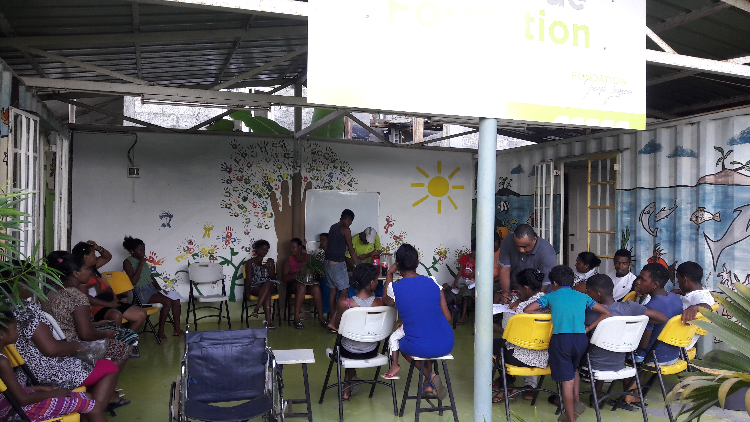
The Chemin Rail Learning Centre
Some other key community development activities (as identified by community members and/or FJL staff) implemented with the support of FJL include:
Activity | Description | Perceived success and sustainability | No. of participants
IT room &  IT classes | Provision of computers for use by community members for educational and professional development purposes  IT classes provided by an IT teacher | Limited success  IT room: 2009 - ongoing  IT classes: 2009 - 2018  There are indications that the IT classes did not function as originally planned.  While there may be various reasons for this, it has been identified that finding an IT teacher with the capacity to work with vulnerable populations has been challenging.  The IT room is still operational at the centre for use by community members. | 20  (IT classes)
Tutoring | After school tutoring for school children | Limited success  2009 - 2018  Children in the locality are not motivated to take part in after school tutoring.  There are indications that this activity may be stopped.  It is recommended that community consultations be undertaken to understand if this is a community priority. | 20
Swimming lessons | Swimming lessons at the public swimming pool in Rivière du Rempart for youngsters aged 8-15 | Unsuccessful  2011 - 2012  Youngsters did not seem particularly interested to take part in this activity.  Activity does not correspond to a need identified by the community. | 10
Adult Literacy course | Adult literacy to members of the community | Successful  2009 - 2013  Community members have expressed their appreciation for the adult literacy course. | 15
Sewing classes | Sewing classes to adults in the community | Successful  2009 - 2013  Community members have expressed their appreciation for sewing classes.  At the end of each year, the finished sewing work of the community members was displayed during an exhibition at the Chemin Rail Learning Centre. | 15
Pickle making and Fruit conservation classes | Pickle making and fruit conservation classes to adult community members, once a week at the Food and Agricultural Research and Extension Research Institute (FAREI) Training School in Wooton | Successful  Started in 2012, over a 3-month period  Community members have expressed their appreciation for this course.  While community members generated income by selling their pickled products for some time, they are now involved in this activity mainly for their own consumption. | 3
Mixed farming classes | Animal rearing and crop production classes by FAREI officers at the Chemin Rail Learning Centre | Limited success  2009 - ongoing  While community members have expressed their appreciation for this activity, attendance rates to courses has been inconsistent. | 8
Dancing classes | Zumba dancing classes to adults in the community | Limited success  Started in 2014, for a period of 9 months  Teacher relocated abroad and a replacement teacher could not be found.  Community members have expressed their appreciation for dancing classes. | 15
Medical support | Provision of extensive medical and surgical interventions for 2 children with physical disabilities | Successful  Both children are now able to participate in the activities of their community. | 2
Beekeeping  lessons  (“Happy Bees” project) | The production of honey by youngsters in Chemin Rail, designed to encourage income-generating activities | Limited success  2015 - ongoing  Activity does not correspond to a need identified by the community.  Youth in Chemin Rail do not seem to be interested or motivated to continue this activity or do not have enough free time to participate in such an activity. | 11
Community gardening | A small plot of land allocated to each household for subsistence planting | Limited success  2016 – Ongoing  Community members have been planting in their own gardens instead of on the shared plot. | 8 households
Marine Eco-guide Training | Marine environment conservation foundation course dispensed by Reef Conservation Mauritius over a one-year period to youngsters aged 13 and above in Péreybère | Successful  2013- 2014  Young community members have expressed their appreciation for this course | 7

3. ADDRESSING THE VULNERABILITIES/NEEDS OF THE COMMUNITY AT CHEMIN RAIL
Data collected from community members and FJL staff, through interviews and group discussions, have shown the positive changes brought about within the community through FJL’s interventions.

3.1 SHELTER: THE CHEMIN RAIL SOCIAL HOUSING PROJECT
The most pressing need of the community at Chemin Rail was the need for decent housing. It took over 10 years of community consultations and project planning and implementation, intertwined with administrative setbacks and bottlenecks, from the time community members were told they would be relocated until they finally got the keys to their new homes.
The construction of 15 housing units by FJL was two-phased. Phase 1 comprised the construction of four housing units in Amaury, a small locality some 5 km from Chemin Rail. And, Phase 2, whose implementation proved to be more difficult due to various setbacks, comprised the construction of 11 housing units in Chemin Rail, only a few metres away from the plot of land occupied by the families.
Four families were relocated in the brand-new housing units at Amaury on July 2015, whereas the remaining 11 families had to wait until 11 December 2017 to receive the keys to their new homes.
“11 Desam 2017: Nou finn gagn lakle pou nou lakaz.”
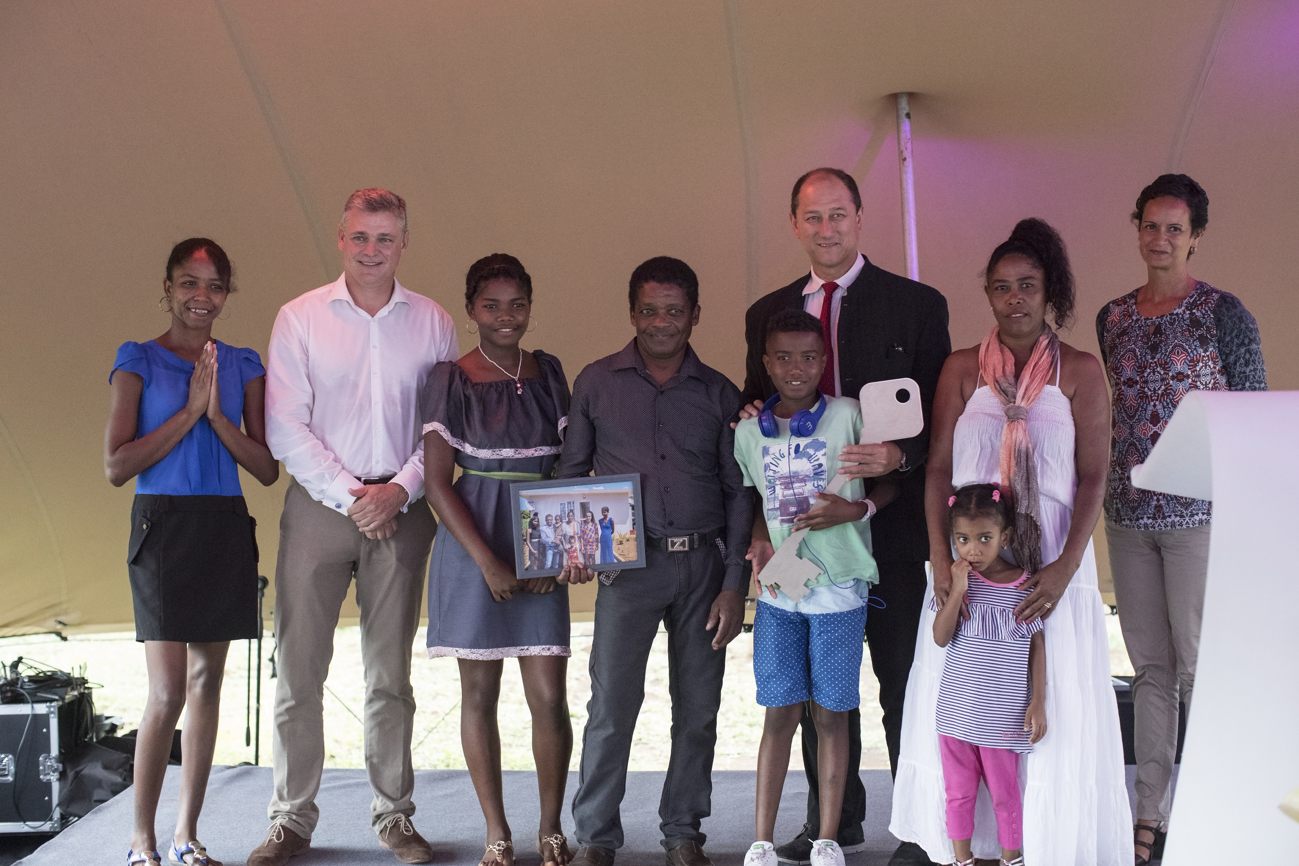
Receiving the keys to their new homes, 11 December 2017

It should be noted that, apart from the 15 families who benefitted from the social housing project, five additional families from Chemin Rail expressed their reluctance to be relocated in new homes. They had invested a lot of resources improving their houses and therefore chose not to benefit from new ones. FJL acknowledged the efforts they made over the years and the autonomy they demonstrated to achieve the goal of building decent homes.

With the help of FJL, legal arrangements have allowed these five families to contribute to a 10-year lease, at the end of which, they would become proud owners of their land. Two out of the five families have completed all the payments of their lease in advance and are now in the process of land excision arrangements. They will soon receive their title deeds as proof of ownership of their land.

The construction of the housing units totalled Rs 27.3 million (11 housing units in Chemin Rail at Rs 21.3 million and four housing units in Amaury at Rs 6.0 million). This represents a total of 69 persons with improved shelters.
Residents of the one-bedroom housing units (Type-1) are currently contributing between Rs 1,500 and Rs 1,600 per month, and those with three-bedroom housing units (Type-2) are contributing between Rs 2,500 and Rs 2,900 per month. The variation in monthly contribution is due to the differences in the areas of the plots of land for each housing unit. These monthly contributions are part of a 10-year lease agreement which will guarantee the ownership of the land and property after this period.
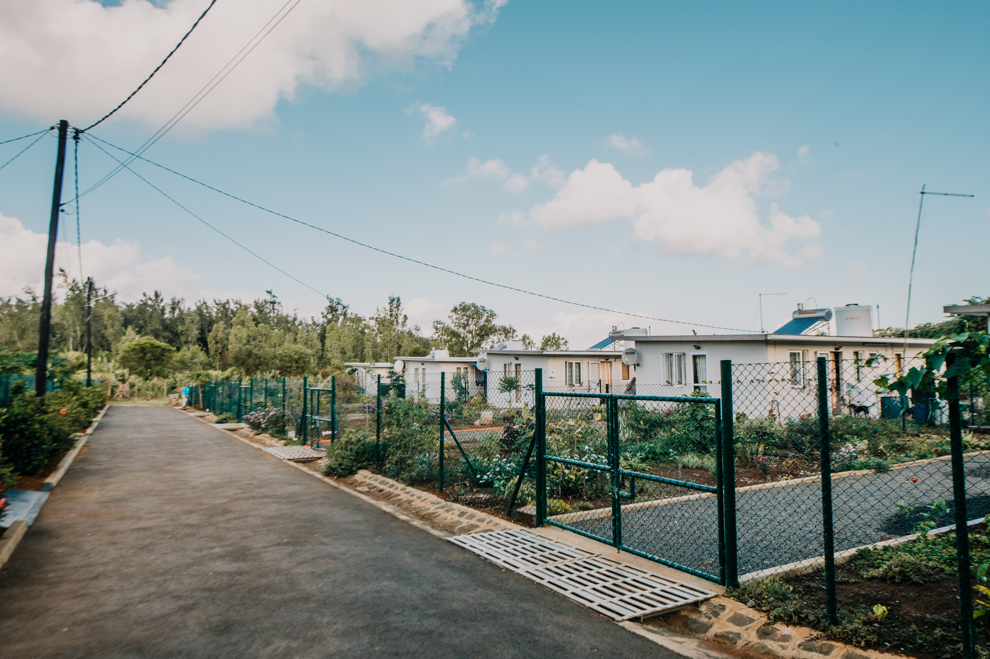
The 11 housing units in Chemin Rail

The construction process of the housing units proved extremely challenging. A key informant interview with the current FJL director, Martine Hennequin (quoted below), recounting the events taking place prior to the construction of the housing units revealed that FJL faced many barriers and setbacks:

- Land ownership: The families in Chemin Rail were illegally occupying the land.

“ They were living on unowned lands and it took time for FJL to understand to which company these lands belonged. They finally found out and negotiated a donation to FJL.”

- Topography: While many community members wanted to stay in their former location, the topography of the land (which included steep angles and rocks) made it too difficult for the construction of safe houses. An alternative site had to be found.

“ In September 2008, FJL acknowledged the fact that it would impossible to build concrete houses on this very rocky land and started looking for an adjacent plot of land.”

- State support: During several meetings with key government officials (including ministers), FJL realised that investing in improved shelter in Chemin Rail was a positive and sustainable project that could gain support.

“ … EAP [Eradicating Absolute Poverty] programme, under the aegis of the Ministry of Finance and Economic Development) was approached. The project was not called social housing but Développement Communautaire Intégré (Integrated Community Development). … EAP started to budget Rs 400,000/house as government participation to the project.”

It is important to note here that the houses FJL planned to build in Chemin Rail were of better standard than the low-cost housing offered at the time by the state.

“ FJL faced a major obstacle : it wanted to build 61m² houses whereas the “low-cost houses” of government were of 38m². So, a compromise was made with the government: please contribute to the project as far as 38m²/house and FJL will fund the remaining 23m²/house. Even then, it was a huge amount of money to be found.”

Eventually, FJL did not receive permission from the Ministry of Social Integration to use its CSR funds for the construction of the housing units. This required FJL to mobilise non-CSR funding for the construction.

“December 2011, government is not willing to go further with the project and FJL decides to move forward on its own and starts raising funds (non-CSR).”

- False promises: While FJL tried to garner state support to realise the construction of improved housing for the community members, many political leaders made promises to the community that they did not keep.

This increased frustration and fuelled discouragement within the community and was a setback in the relationship of trust that FJL had built with the community. FJL faced many difficulties in explaining these challenges to the community members, who struggled to understand the many political barriers to the construction of their homes.

To support the integration of community members in their new homes, FJL developed and implemented (internally) a 48-week “Housekeeping” programme. The Housekeeping Programme is a training programme designed to build local capacity to manage and maintain their new households and includes modules such as: Life Skills, Household Maintenance and Sustainable Environment.

3.2 EDUCATION
FJL guided many children towards non-formal education through the Adolescent Non-Formal Education Network (ANFEN) centre, Etoile de Mer, in Roche Noire. With support from FJL, the community has also seen a general improvement in parents’ interest and responsibility towards their children’s education. FJL’s social workers helped parents to understand their roles in their children’s education, encouraged them to participate in their children’s school lives, and gave them the opportunity to come to school premises to see how their children were faring.
Currently, all children in the locality are attending school with several attending and completing secondary school. The primary school dropout rate has decreased considerably. With support from FJL, Katoosia Mélanie Gérard (a young member of the Community) is currently completing a university degree in Mass Communication. A full interview with Mélanie is annexed to the retrospective study (Annex 1).

3.3 HEALTH
A significant improvement in the overall health has been reported. There are noticeable reductions in cases of gastrointestinal diseases and skin infections, and the residents report lower stress levels and a significant improvement in their mental health. In addition, reports from FJL staff suggest that substance abuse and violence, which share a cause and consequence relationship, have been markedly reduced.
Water, sanitation and hygiene conditions have substantially improved, with all housing units equipped with safe drinking water sources, proper sanitation facilities, including flush toilets and waste water management systems.
Previously, community members were relying mainly on traditional medicine for health care. With support from FJL and its social workers:
- Community members have been provided access to professional counselling services for a number of years; FJL covered the costs of therapy sessions with psychologists in view of helping those community members living with mental health problems and emotional challenges.
- Two physically disabled children have received the required medical support (Moïse Lauricourt and Maëva Isidore). There are currently 6 persons living with a disability (physical and mental) in Chemin Rail. They have benefitted from the support on FJL in terms of their special educational and vocational needs.
- Household members are displaying improved health and hygiene practices;
- A reduction in substance abuse, with two successful cases of rehabilitation, has been reported; and
- Community members have improved access to public health facilities.
It is important to note some of the challenges faced by FJL in the implementation of health-related interventions: As reported by FJL staff, lack of self-efficacy and self-confidence often prevented parents from following-up on and sustaining their children’s medical care and treatment initiated by FJL. FJL staff have realised that a change in mindset or cultural norms and beliefs takes a long time. While this was discouraging to FJL staff, it is positive to note that FJL was able to adapt to the cultural norms of the community and maintain its support.

3.4 ENVIRONMENT
Several key environmental activities were implemented in Chemin Rail. Besides clean-up days conducted in the community, FJL worked with community members to improve their agricultural practices (such as animal breeding), to ensure proper containment and/or disposal of associated waste matter. FJL also advocated on behalf of the community for the relocation of a large-scale pig breeding operation that was contributing to an unhealthy and unhygienic environment.

3.5 EMPLOYMENT
While unemployment rates were high, with the support of FJL, current unemployment rates stand at 0%. FJL supported the community by linking them to existing services and potential employers. As part of the agreement to build their homes, residents are also required to seek employment so that they can contribute to some of the building and land costs and thus take ownership of their homes. Some community members have reported working two or more jobs to increase their monthly income.

3.6 SAFETY AND SECURITY
It is clear that the new housing units have improved the lives of the community members. They feel a greater sense of safety and security in their new homes that are built to resist natural disasters. Community members also report that they feel more comfortable knowing that their valuables are safe in their homes and that their children are less exposed to physical, verbal and sexual violence, are able to run around and play in the gardens and the neighbourhood.
“Nou santi nou an sekirite aster.”
This improved sense of safety and security has also enhanced the social cohesion within the community members (although it is worth pointing out that four families were moved to Amaury). In addition, community members expressed that while they now have their privacy, they also have sufficient space to host or visit their neighbours and friends.
“Aster nou santi nou lib.”

3.7 A FEW INVESTMENT FIGURES
During the 12 years of involvement in Chemin Rail, FJL invested approximately Rs 33 million in the development of the community. This sum relates to
- Funds disbursed from 2007 to 2016 for the:

- Construction of the housing units in Chemin Rail and Amaury;
- Constriction of the learning centre in Chemin Rail;
- Medical support (counselling and surgery) provided to community members;
- Salaries of two social workers;
- Other projects and activities undertaken by FJL in the community.

- Funds disbursed for the latest community projects and activities funded by FJL:

- In 2016-2017 (approximately Rs 185,000)
- In 2017-2018, (approximately Rs 214,000)

4. PROFILE OF HOUSEHOLDS, 2018
The table below depicts the demographic and socio-economic profile, as at 2018, of the 15 households who benefitted from FJL’s social housing project.
HH No. | No. of HH members | No. of adults and children | Marital status of adults in HH | Age of adults and children | Occupation of adult HH members | Highest educational level of HH members
1 | 3 | Adults: 2  Children: 1 | 1 single;  1 widower | Adults: 20; 61  Children: 16 | Retired;  Basic Invalid Pension Beneficiary | Secondary level - Form 4
2 | 3 | Adults: 3 | 2 single;  1 widow | Adults: 26; 29; 51 | Labourer; Maintenance officer; Mason/Casual worker | Vocational training - NTC 1
3 | 2 | Adults: 2 | 1 single;  1 widow | Adults: 22; 70 | Student;  Retired | Tertiary level - undergraduate
4 | 2 | Adults: 2 | 1 married couple; | Adults: 45; 55 | Driver; Unknown | CPE
5 | 4 | Adults: 3  Children: 1 | 1 married couple;  1 single | Adults: 25; 43; 50  Children: 16 | Mason; Casual worker; Basic Invalid Pension Beneficiary | CPE
6 | 6 | Adults: 3  Children: 3 | 1 married couple;  1 single | Adults: 18; 37; 40  Children: 9; 10; 16 | Fisherman; Housemaid; Student | Secondary level - Form 6
7 | 4 | Adults: 4 | 1 married couple;  2 single | Adults: 19; 21; 43; 45 | Mason;  Casual worker; Basin Invalid Pension Beneficiary; Casual worker | CPE
8 | 5 | Adults: 3 Children: 2 | 1 cohabiting couple;  1 single | Adults: 19; 45; 50  Children: 9; 16 | Housemaid; Casual worker; Unemployed | Vocational training - NTC 1
9 | 3 | Adults: 2  Children: 1 | 1 cohabiting couple | Adults: 48; 50  Children: 14 | Lorry Helper; Babysitter | Pre-vocational training - Level 3
10 | 1 | Adult: 1 | 1 widow | Adult: 75 | Retired | Primary level - Standard 2
11 | 2 | Adults: 2 | 1 married couple | Adults: 53; 62 | Retired/Cleaner; Fisherman | CPE
12 | 2 | Adults: 2 | 1 married couple | Adults: 28; 35 | Mason;  Housewife | Secondary level - Form 3
13 | 5 | Adults: 2  Children: 3 | 1 married couple | Adults: 30; 35  Children: 5; 11; 16 | Factory helper;  Housewife/Casual worker | Secondary level - Form 2
14 | 4 | Adults: 4 | 2 married couples | Adults: 28; 30; 62; 65 | Retired; Retired;  JCB operator;  Housewife/Entrepreneur | Secondary level - Form 2
15 | 5 | Adults: 2 Children: 3 | 1 married couple | Adults: 35; 37  Children: 2;12;17 | Housewife;  Occasional worker | Secondary level - Form 3

5. SUMMARY OF VULNERABILITIES/NEEDS ADDRESSED BY FJL
The table below is a summary of the community vulnerabilities/needs that have been identified and addressed by FJL.
Period | Community Vulnerabilities/Needs Identified and Addressed
 | Unemployment | Environment | Health and care | Safety and security | Education | Shelter
As at 2005 | • High unemployment rate  • Those employed occupied very low paid jobs (fisherman, mason, maintenance officer, etc.) | • Animal rearing in unsanitary conditions  • Stray dogs were a nuisance  • No proper waste water management | • Only one water source  • Only 4 sanitary facilities  • High prevalence of skin infections and water borne diseases  • Prevalence of substance and violence  • High stress levels  • Cases of mental health issues | • Children at risk of physical, verbal and sexual violence  • Families did not feel safe  • Household valuables were at risk of being stolen or lost | • Low education levels  • Children unable to adapt to state education system  • High primary school drop-out rate  • Minimal parental responsibility and interest in the education of their children | • Families lived in makeshift houses  • Families were vulnerable to bad weather conditions including, cyclones and heavy rains
As at 2018 | • Zero unemployment  • Some community members work two or more jobs to increase their monthly income | • A few households practice animal rearing in proper sanitary conditions  • Stray dogs not a nuisance as houses are fenced  • All household units are equipped with proper sewage system | • All household units equipped with running water  • All households units equipped with adequate sanitary facilities  • Noticeable reductions in cases of gastrointestinal diseases and skin infections  • Substance abuse and violence reduced  • Low stress levels reported  • Significant improvement in mental health of community members | • Children are less exposed to physical, verbal and sexual violence  • Valuables are kept safe inside their new homes  • Families feel safe, have more privacy and more space | • All children attend school  • One young community member pursuing tertiary studies  • Primary school drop-out rate nil  • Except for two families, parents show interest in the education of their children | • Families living in fully-equipped concrete houses; a few have reported construction flaws while two families are deprived of hot water  • Families are sheltered from bad weather conditions

6. THE REASEARCH TEAM IN CHEMIN RAIL
For the purpose of this report, the research team conducted meetings with community members on several occasions in Chemin Rail. These meetings allowed the team to gather useful and crucial qualitative data on the community and its development over the years. The research team used several methods, namely, informant interviews, observation and focus groups. Community data was also obtained through secondary analysis of records, documents and other previously collected data.
During the research team visits in Chemin Rail, community members were very welcoming and there was a genuine sense of connection, communication and sharing between the team and the community members. In addition, community members showed great interest and concern about the study.
During the last meeting with community members, which was very fruitful and productive, a timeline exercise, which is a graphic method used to show events taking place over time, was used as participatory tool. It was followed by a focus group discussion. This participatory tool helped the representatives recount and narrate events that took place in their community from as far back as they could remember till the present day
At the start of the meeting, the aims of the study and focus group rules were discussed, and consent was sought for participation. After a research team member drew a long timeline on a large piece of paper, community representatives were asked to write, draw or symbolise, with markers, all the important events that occurred within their community. This exercise was carried out in chronological order and using specific dates for each event. While the research team members acted as facilitators, the timeline was analysed and discussed with the community representatives. The research team obtained a general idea of the community’s history and the sequence of events that took place in Chemin Rail.

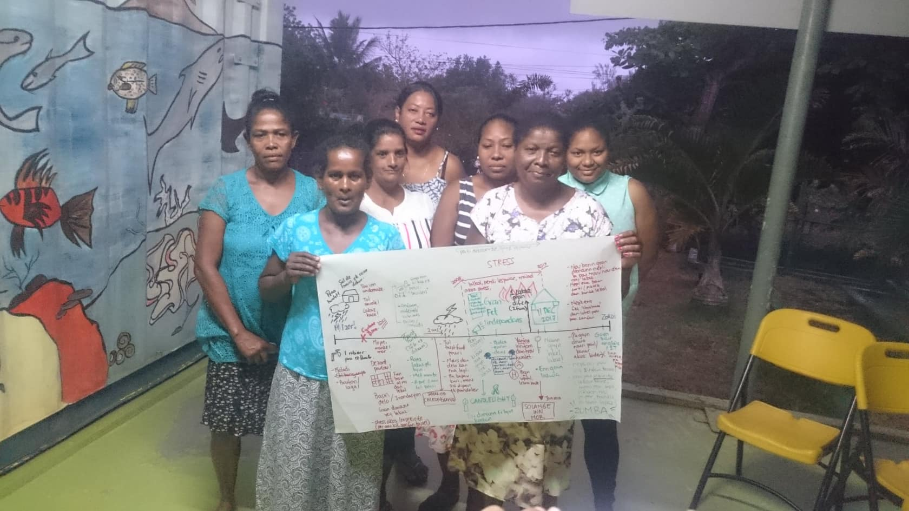
Timeline drawn by the community members
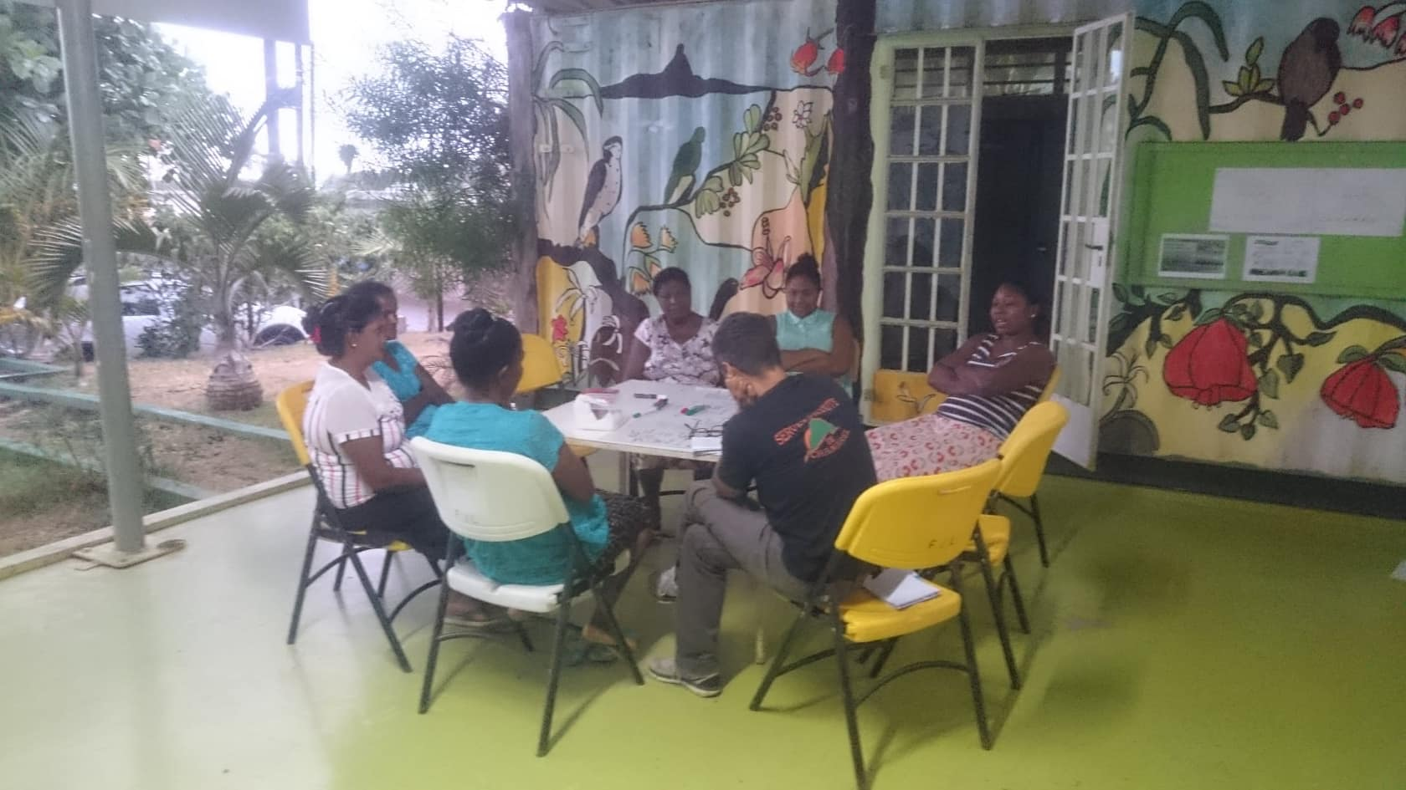Focus group discussion

7. CONCLUSION AND WAY FORWARD
FJL’s investment in the community of Chemin Rail has helped facilitate the development of this once at-risk community. The 12 years of intervention and support has resulted in some concrete development initiatives including:
- A reduction in unemployment rates;
- An increase in the level of formal education levels;
- A general improvement in physical and mental health of community members;
- A considerable reduction in levels of insecurity due to substance abuse, violence and poor shelter; and
- An improvement in household standards, as well as an improvement in the standard of living.
While community members are generally employed in low income generating jobs, the investments made in education (including helping parents to understand their roles and responsibilities in the education of their children) can help ensure that young adults will have access to more employment opportunities. This can help increase household disposable income, and provide community members with greater access to development initiatives for themselves, their household and their community.
By improving access to improved housing and basic health and hygiene tools, community members are having most of their basic needs met. While community members may still be having some issues with their new houses, these are issues that can be easily dealt with, and should thus be investigated and resolved as soon as possible. By having their basic needs met, the community of Chemin Rail now has a strong foundation to reflect, analyse and invest in their future development.
FJL’s investment in Chemin Rail has highlighted many challenges and lessons learnt. Activities implemented unsuccessfully or with limited success indicate insufficient community consultation and planning in the design and development of activities:
- While many community meetings were held, no participatory tools were used to ensure that community members were able to reflect, analyse and share their views and opinions. Ensuring that communities have a voice and are key actors in the development of their communities, will increase the success of implementation and encourage sustainable development.
- A few activities in Chemin Rail seemed to have been developed haphazardly. This meant that many key items in programme design have been omitted, including a strong monitoring and evaluation component, and an exit strategy.
This study of the interventions implemented in Chemin Rail, clearly demonstrate a positive effect that FJL has had on the development of the community. Not only have basic needs been met, but local capacity has been, and continues to be, developed. This improved local capacity can help ensure a multiplier effect for activities already implemented, and thus ensure sustainable development at the community level.
While several challenges, weaknesses and errors were identified, FJL has drawn valuable lessons from its interventions at Chemin Rail. These lessons learnt will ensure that any future community development projects, programmes or activities designed by FJL will better meet the needs of vulnerable communities.

“Nou fami erez aster.”

8. ANNEXES

8.1 ANNEX 1

TELEPHONE INTERVIEW
Full name of interviewee: Katoosia Mélanie Gérard
Age: 21 years old
Primary school attended: Bheewa Mahadoo Government School, Rivière du Rempart
Secondary school attended: Loreto College Port Louis
Tertiary institution: Currently attending Charles Telfair Institute (CTI) in Moka.
Course at CTI: Mass communication, specialised in web media and corporate screen production (1 year left to complete course)
Family status: Lives with paternal grandmother (72 years old). Mother lives separately at another location. Father has remarried and has other children. Father lives in Chemin Rail but not in the same house.
INTERVIEW RESPONSES (VERBATIM IN KREOL):
PAST
- Pa ti fasil ditou avan.
- Kan gro lapli tonbe, kaye ek liv ti pe mouye. Pa gayn letan met sek pou landemin al lekol. Lerla mo ti pe swiv ek kamarad.
- Pa ti ena internet, mo ti bizin swa pran package lor portab, swa al kot kamarad ou dan cyber café, pou fer bann resers pou mo bann devwar.
- Mo ti pe per pou mars depi bistop ziska mo lakaz kan mo sorti lekol. Mo papa ti bizin atann mwa lor bistop toulezour.
- Ti ena moustik ek karya plin. Mo ti pe gayn karya dan mo bann liv.
- Mo ti pe gayn tou kalite alerzi ek bouton.
- Ti ena boukou lager dan landrwa. Souvan mo pa kapav aprann akoz tapaz ek lager.
- Lepok mo ti pe al lekol segonder, mo ti pe pran leson pou tou size. Mo granmer touletan inn support mwa kote letid. Mo granmer ek mo papa ti pe trase pou pey mo bann leson, mwatye mwatye.
PRESENT
- Kan monn gayn mo nouvo lakaz, mo ti pe resi gard mo bann liv bien.
- Lavi pli smooth, pli a lez, tou bann zafer an lord ek prop.
- O nivo lasante, mo bann alerzi inn ale, mo nepli gayn bouton asterla.
- Asterla pli safe kan mo rant lakaz depi lekol. Mo nepli per pou mars tousel.
- Asterla mo ena wifi, pli fasil. Mo kapav aprann pli vit.
- Mo trouv mo lanvironnman pli apropriye aster. Nepli ena lager.
- Aster ena bann nouvo regleman (nouvo lakaz, nouvo reg) ex. bizin res bien ar vwazin, pa met lamisik tro for, pa kokin kot vwazin. Mo kapav revize, fer devwar bien aster.
FUTURE
- Mo lavenir meyer aster. Sirtou kote letid. Fondasion pe finans mo letid. Si pa ti ena banla, mo pa ti pou kone ki-ete sa film production. Mo pa ti pou kot mo ete zordi. Banla inn bien ed mwa.
- La kominote trouv mwa kouma enn exzanp. Mo anvi motiv bann lezot zanfan dan Chemin Rail pou ariv lwin dan zot bann letid. Si mwa monn kapav, zot si zot pou kapav.
- Avek sa letid mo pe fer la mo anvi travay dan domenn film production, kitfwa antan ki assistant film producer.
FINAL WORDS
- Mo pa ti pou kwar mo ti pou resi ariv ziska-la enn zour. Mo ti tou-letan panse « Nek bann dimounn risar ki kapav fer letid liniversite. Nou tou pov isi, nou pa pou kapav sorti dan la povrete ». Me nou finn resi.

